### ***Course: CSC14003 – Introduction to Artificial Intelligence***

### ***Class 21CLC – Term III/2022-2023***

Homework 02

***Submission Notices:***

* *Conduct your homework by filling answers into the placeholders in this file (in Microsoft Word format).*

*Questions are shown in black color, instructions/hints are shown in italics and blue color, and your content should use any color that is different from those.*

* *After completing your homework, prepare the file for submission by exporting the Word file (filled with answers) to a PDF file, whose filename follows the following format,*

*<StudentID-1>_<StudentID-2>_HW01.pdf (Student IDs are sorted in ascending order)*

*E.g.,* ***2112001_2112002_HW02.pdf***

*and then submit the file to Moodle directly WITHOUT any kinds of compression (.zip, .rar, .tar, etc.).*

* *Note that you will get zero credit for any careless mistake, including, but not limited to, the following things.*
  1. *Wrong file/filename format, e.g., not a pdf file, use “-” instead of “_” for separators, etc.*
  2. *Disorder format of problems and answers*
  3. *Conducted not in English*
  4. *Cheating, i.e., copying other students’ works or letting other students copy your work.*

**Problem 1. (2pt)** Answer the following simple questions.

*Please write your answer in the table*

|  |  |
| --- | --- |
| **Questions (0.5pt each)** | ***Filling in the blanks*** |
| What is the primary objective of local search? | *The primary objective of local search is* an algorithm of finding reasonable solutions of an optimization problem in large or infinite (continuous) state spaces without exploring the entire state spaces. |
| How does local search differ from global search algorithms? | *Local search algorithms* are focused on a particular region of the search space to find a good solution quickly without exploring the entire search spaces. |
| What are the key components of a Constraint Satisfaction Problem (CSP)? | *The key components of a Constraint Satisfaction Problem (CSP) are*: Variables, Constraints, Domain |
| In the context of hill-climbing, what is the role of the objective function or evaluation function? | *The objective function or evaluation function in hill-climbing is* determining the quality of a solution and directing the search towards improved solutions. |

**Problem 2. (1pt)** For each of the following question, please choose either True or False and give a brief explanation.

*Please write your answer in the table*

|  |  |  |
| --- | --- | --- |
| **Claims** | **True/False** | **Explanation** |
| Hill-climbing algorithms with random restarts can overcome the issue of getting stuck in local optima and are guaranteed to find the global optimum solution. | False | Because I think that there are a few existing cases that do not guarantee to find the global optimum solution. There are many factors that affect to the solution such as: a bad objective function, random restarts can still miss the global optimum solution if the search space is very large and complex, |
| Simulated annealing guarantees convergence to the global optimum solution if given enough computational resources and a properly designed cooling schedule. | False |  |

**Problem 3. (2pts)** Consider the game tree below, which contains maximizer nodes, minimizer nodes, and chance nodes. For the chance nodes the probability of each outcome is equally likely.

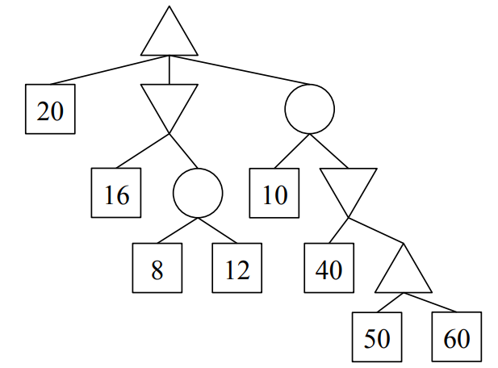

1. (1pt) Fill in the values of each of the nodes.
2. (1pt) Is pruning possible? If yes, please cross out the branches that can be pruned. If not, give a brief justification.

*Please write your answer in the table*

|  |
| --- |
|  |

**Problem 4. (2pts)** Given *Constraint Satisfaction Problem*. In the given map below, there are 14 regions corresponding to 14 capital letters (from ‘A’ to ‘M’).

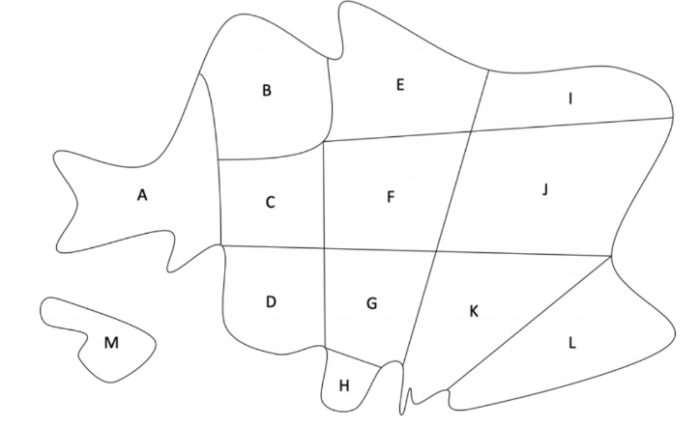

1. (1pt) Please find the minimum number of colors needed to color the regions with the constraint that no two adjacent regions have the same color. You just need to state the minimum number and give one sample of the colors assigned to each of the regions that satisfy the constraint.

*Please present your work in the table*

|  |
| --- |
| A white background with black and white clouds  Description automatically generated  The minimum number of colors needed is 3 |

1. (1pt) Assuming that there are three colors: red, blue, and green. Initially, we can give every region one of the colors. It means that the color domains of each of the regions are {red, blue, green}. Then, we assign the region F to have green color. What is the result of the Forward Checking algorithm?

*Please present your work in the table*

|  |
| --- |
|  |

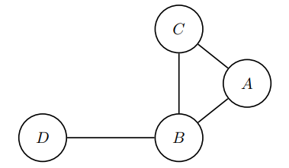**Problem 5. (3pts)** You are given a constraint graph for a Constraint Satisfaction Problem as follows. The domains of all variables are indicated in the table, and the binary constraints are as follows:

$A>B$

$A≠C$

$C>B$

$D<B$

|  |  |  |  |  |
| --- | --- | --- | --- | --- |
| A | 0 | 1 | 2 | 3 |
| B | 0 | 1 | 2 | 3 |
| C | 0 | 1 | 2 | 3 |
| D | 0 | 1 | 2 | 3 |

1. (1pt) Enforce arc consistency on this graph and indicate what the domains of all the variables are after arc consistency is enforced, in the table below by crossing out eliminated values from the domains.

|  |  |  |  |  |
| --- | --- | --- | --- | --- |
| A | 0 | 1 | 2 | 3 |
| B | 0 | 1 | 2 | 3 |
| C | 0 | 1 | 2 | 3 |
| D | 0 | 1 | 2 | 3 |

1. (2pts) Now suppose you are given a different CSP with variables still being A, B, C, D, but you are not given the constraints. The domains of variables remaining after enforcing arc consistency for this CSP are given to you below.

|  |  |  |  |  |
| --- | --- | --- | --- | --- |
| A |  |  | 2 | 3 |
| B |  |  | 2 | 3 |
| C | 0 | 1 | 2 |  |
| D |  |  | 2 | 3 |

Select all of the following options which can be inferred given just this information. 🞎 The CSP may have no solution.

🞎 The CSP may have a solution.

🞎 The CSP may have exactly one solution.

🞎 The CSP may have more than one solution.

🞎 The CSP must have more than one solution.

🞎 None of the above.

*Please give an explanation in this table*

|  |
| --- |
|  |